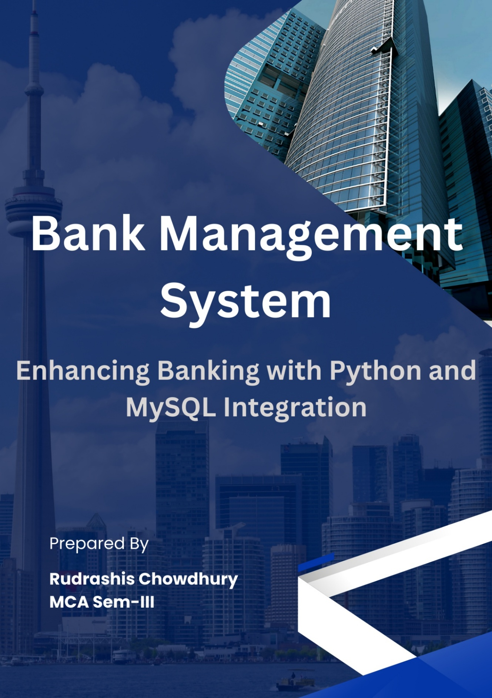

CONTENTS

SL.NO | TOPIC | Page No
1. | Hardware and Software required | 2
2. | Introduction | 3-5
3. | Python Source Code | 6-17
4. | MySQL Databases | 18-23
5. | Outputs | 24-30
6. | Bibliography | 31

HARDWARES AND SOFTWARES
REQUIRED
HARDWARES
- Desktop Computer/Laptop
- Windows 10
- Computers
- Server
- Database software (MySQL)
- Python development environment
SOFTWARES
- Python programming language
- MySQL database server
- Python MySQL Connector
- Operating system (Windows, Linux, or macOS)

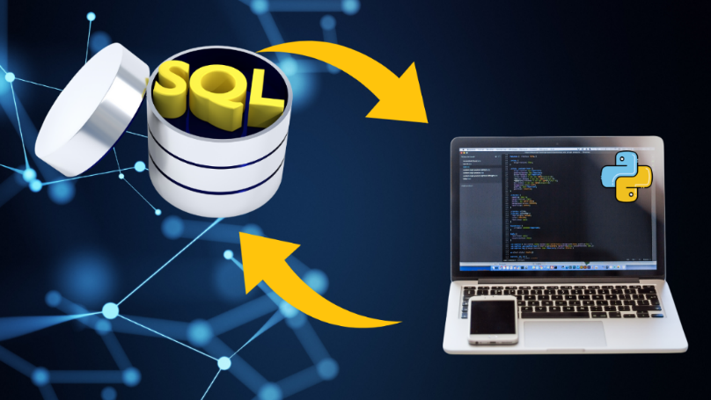

INTRODUCTION
Financial systems have always followed technological advancements. Banking, one of the oldest human institutions, went from ledger books to digital systems over the last century. This was driven by the need for efficiency and transparency. Initially, computers in banks were limited to standalone systems for basic operations. But with integrated systems and databases, banking changed, and we got real-time, customer centric services.
In the late 20th century, relational database management systems and programming languages changed how banks handled transactions. Python, a versatile and user-friendly language and MySQL, a powerful relational database system became the tools to automate banking services. Python and MySQL together provided a solid backend for banking applications and seamless data interaction. They bridged the gap between technical capabilities and user expectations.
Today we need systems that go beyond basic features. Bank Management System uses Python for its user-friendly interface and MySQL for robust data storage and management. This combination caters to both administrative and user needs from account management to real-time balance updates, loan tracking and user feedback system for seamless banking.
The project Bank Management System presented here represents a pivotal solution in the field of financial management, blending the sophistication of MySQL as the database backend with the dynamic capabilities of Python. This amalgamation results in a comprehensive system that caters to both administrative and user functionalities, streamlining processes related to account management, feedback collection, and loan tracking.
Evolution of Management Systems using Python and MySQL Connector
The evolution of management systems, especially in the banking sector, has witnessed a paradigm shift with the advent of powerful programming languages like Python and robust database management systems such as MySQL. Python, recognized for its simplicity, readability, and versatility, serves as the ideal frontend language for developing user-friendly interfaces. MySQL, on the other hand, provides a reliable and scalable database solution, ensuring the secure storage and retrieval of crucial banking information.
The integration of these technologies facilitates a seamless flow of data, enabling real-time interactions between users and the banking system. The dynamic connectivity offered by the MySQL Python Connector ensures efficient communication between the Python application and the MySQL database.
Purpose of Bank Management System
The Bank Management System project aims to address several key challenges in traditional banking operations. By leveraging Python's intuitive programming features and MySQL's robust data management capabilities, the system provides an agile and user-centric platform for both customers and administrators.

Objectives
The Overall objective of this research is to evaluate the implementation of Python and MySQL in bank management.

Specific objectives are:
- To develop a modular and scalable bank management system.
- To test the Python-MySQL integration in real-time.
- To measure user satisfaction and operational improvements.

Justification
This research is relevant because it follows the digital transformation in the banking industry. By using Python and MySQL, this research will provide insights in creating user friendly, secure and efficient systems. It will contribute to both theoretical and practical in financial technology.

Methodology
This research is a mixed method. The main investigation is to develop a prototype Bank Management System using Python and MySQL. Qualitative analysis will be done through user feedback on the system’s interface and features. Quantitative metrics such as response time and data accuracy will be measured. The study will involve end-users and administrative personnel, using case studies to test the system in real-world.

Hypotheses
- Utilizing Python's user-friendly interface can improve the accessibility of banking operations for non-technical users.
- MySQL's robust database management system will enhance data security and operational reliability.
- A seamless connection between Python and MySQL via connector modules can provide real-time data synchronization, reducing processing time and errors.

User Functions
- Add Account: Users can easily open new accounts by providing essential details, streamlining the account creation process.
- View Balance: Account holders can check their account balance in real-time, fostering transparency and financial awareness.
- Give Feedback: The system facilitates a channel for users to provide feedback, ensuring continuous improvement based on user input.
- View Transaction History: Users have access to their transaction history, aiding financial record-keeping and reconciliation.

Admin Functions
- Add New Accounts: Administrators can add new accounts to the system, streamlining the process of on boarding new customers.
- View Loan Details: Admin have access to comprehensive loan details, enabling effective management and decision-making.
- Update Loan Status: The system empowers administrators to update the status of loans, track repayments and ensuring accurate record-keeping.
- View Loan Defaulters: Admin can identify and view details of customers who have defaulted on loan payments for a specified period.
- View User Feedback: The system consolidates user feedback, providing valuable insights into user experiences and concerns.

SOURCE CODE

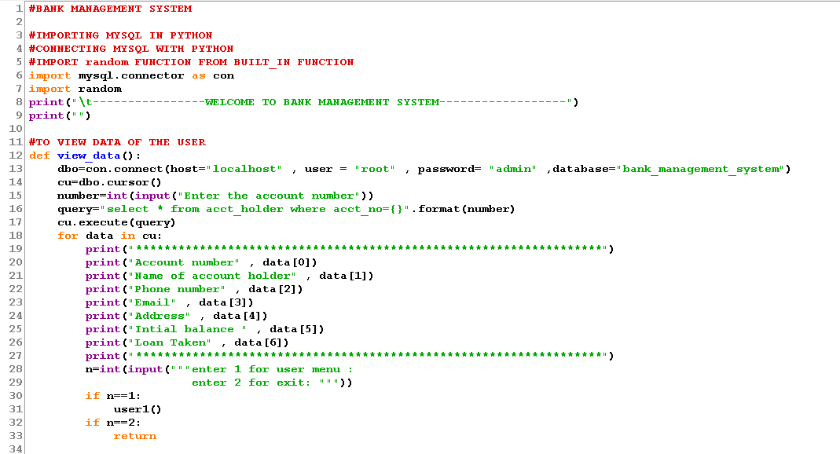

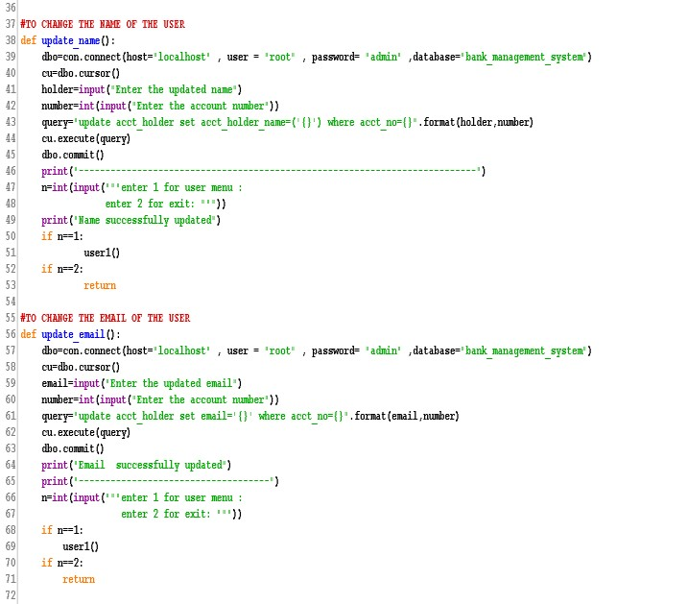

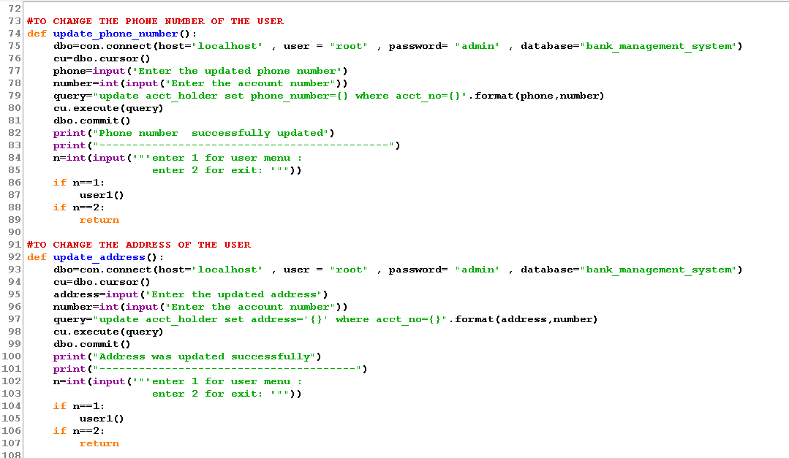

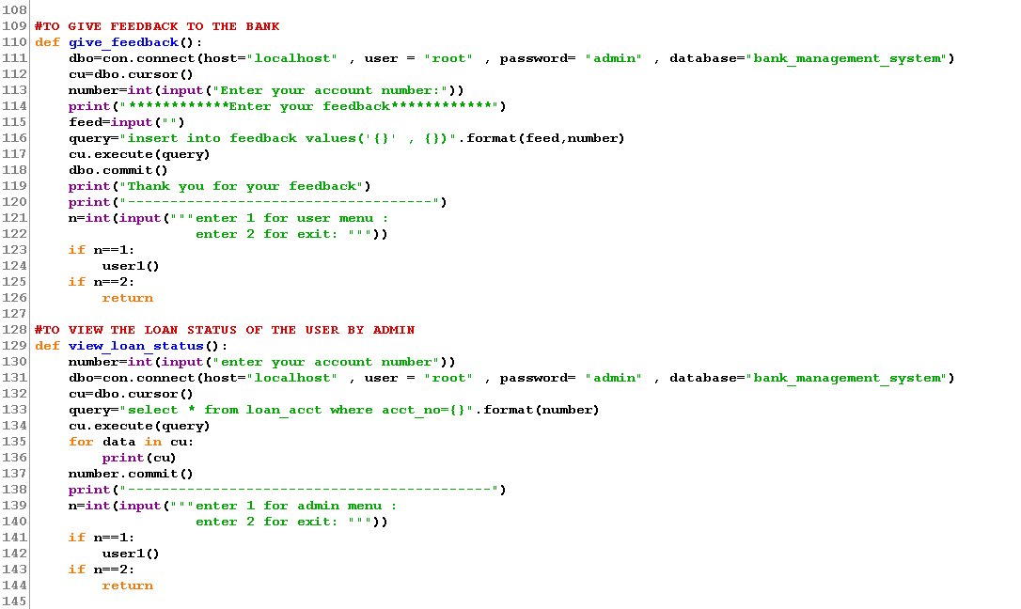

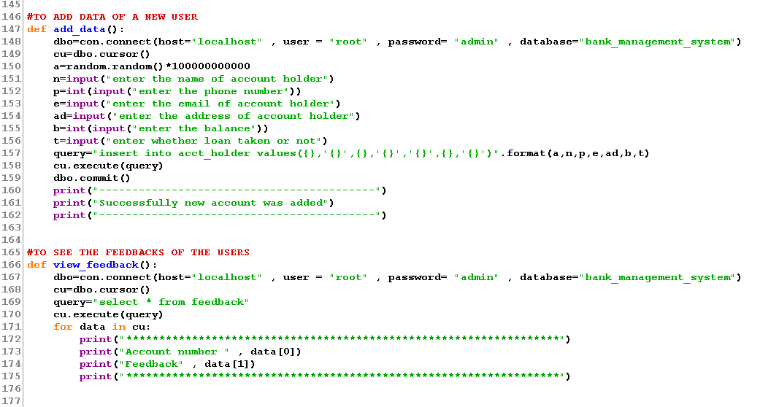

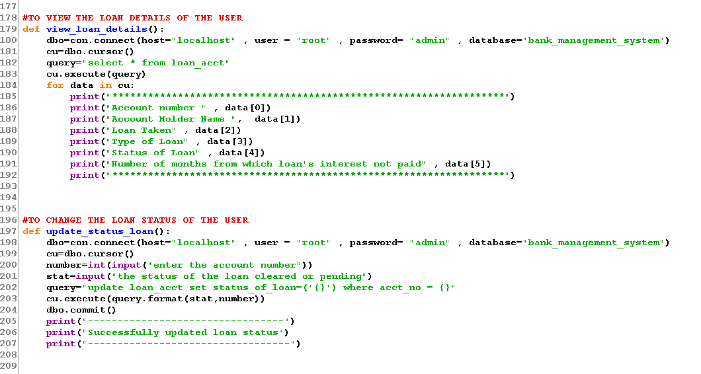

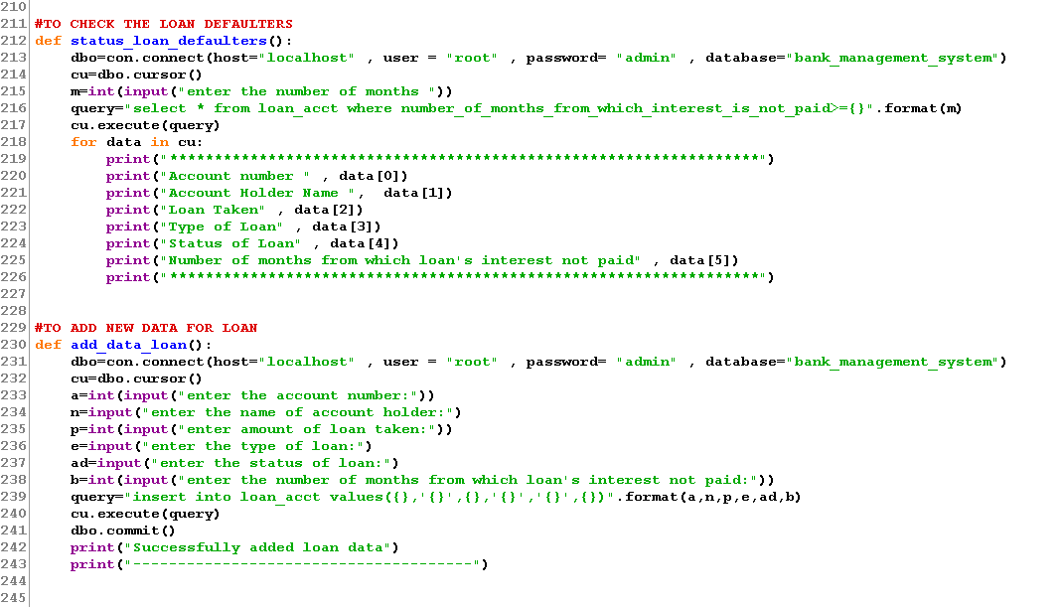

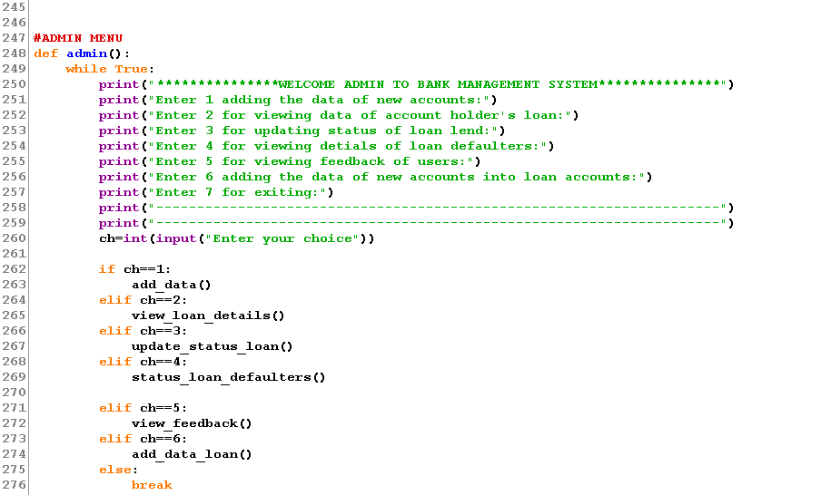

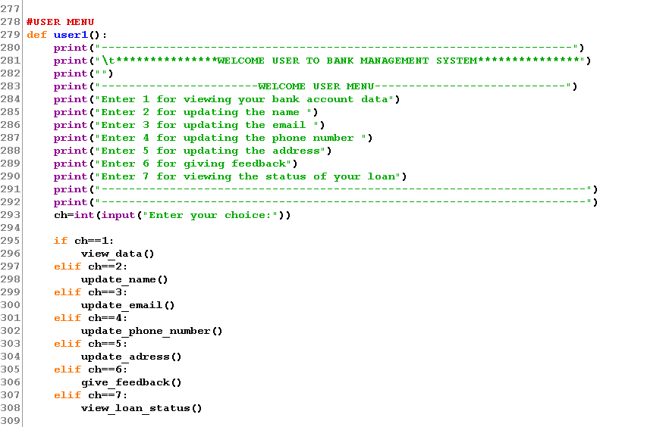

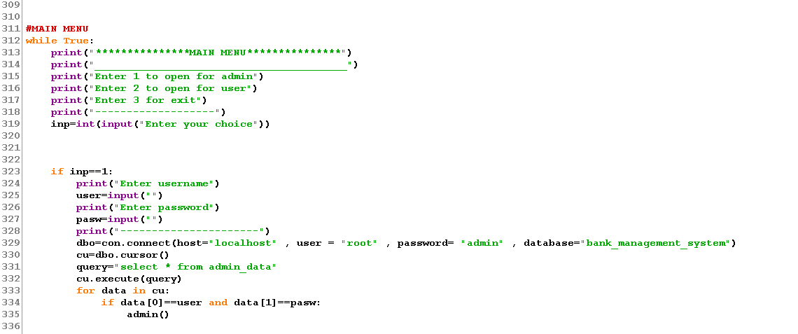

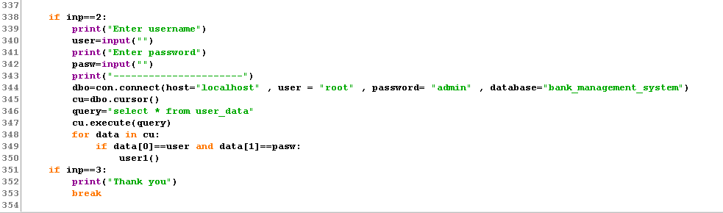

DATABASE

USE OF DATABASE AND SHOW ALL TABLE IN THE DATABASE:
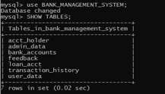

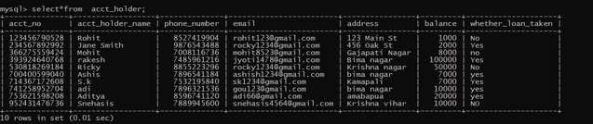
DATA IN ACCOUNT HOLDER TABLE:


DESCRIBE ADMIN TABLE:

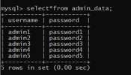

DATA IN ADMIN TABLE :

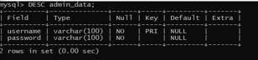

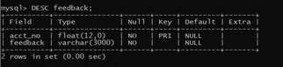
DESCRIBE FEEDBACK TABLE:

SHOW FEEDBACK OF USER:
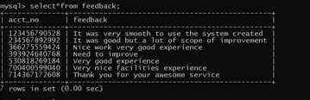

DESCRIBE LOAN DETAILS TABLE:

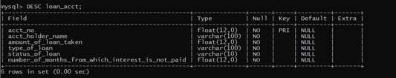

DATA IN LOAN DETAILS TABLE
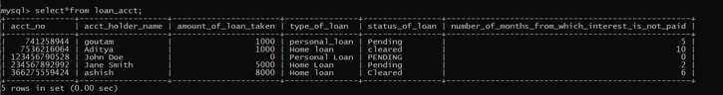

DESCRIBE TRANSACTION TABLE:
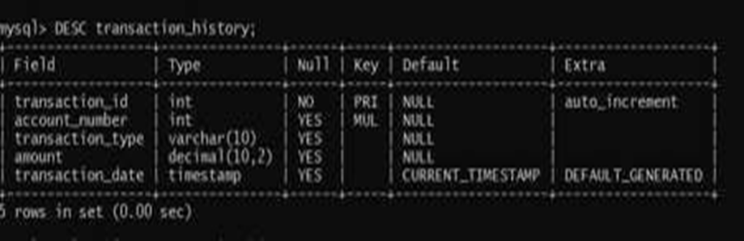
SHOW TRANSACTION HISTORY OF THE USERS:
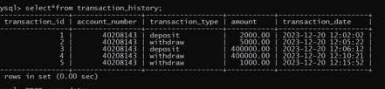

DESCRIBE USER_DATA:
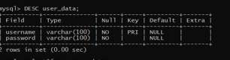

DATA IN USER TABLE:
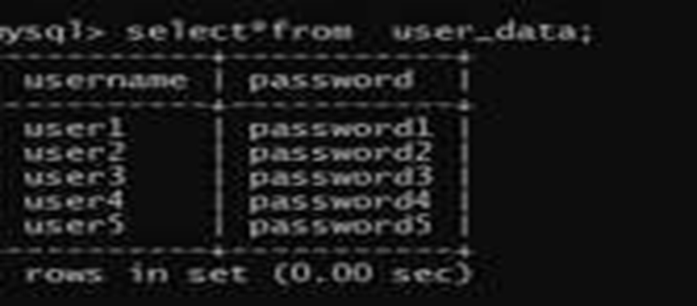

ACCOUNT HOLDER DATA:
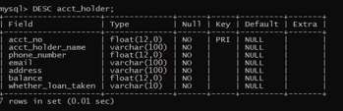

MAIN MENU:
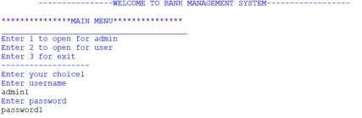

ADMIN MENU:
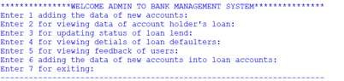

ADDING THE DATA OF NEW ACCOUNT:
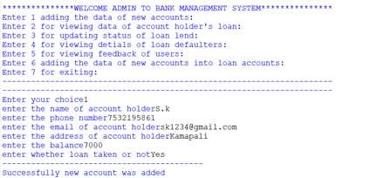

FOR VIEWING DATA OF ACCOUNT HOLDERS LOAN:
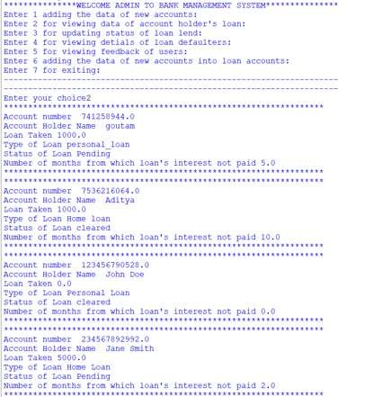

FOR UPDATING STATUS OF LOAN LEND:
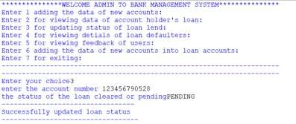

FOR VIEWING DETAILS OF LOAN DEFAULTERS:
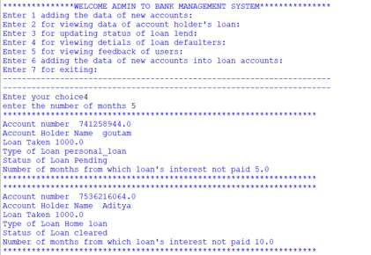

FOR VIEWING FEEDBACK OF USERS:
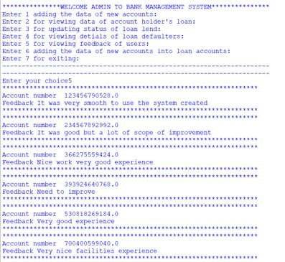

ADDING THE DATA OF NEW ACCOUNTS INTO LOAN ACCOUNTS:
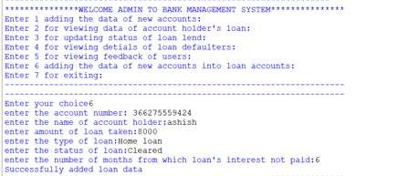

USER MENU:
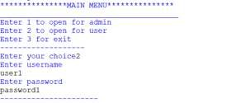

FOR VIEWING YOUR BANK:
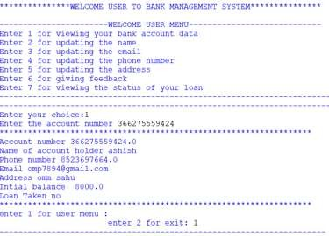

FOR UPDATING THE NAME:
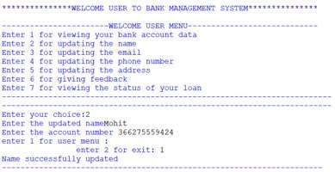

FOR UPDATING THE MAIL:
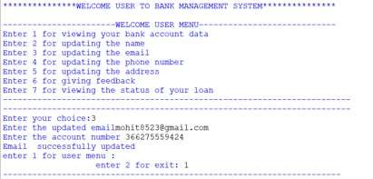

FOR UPDATING THE PHONE NUMBER:
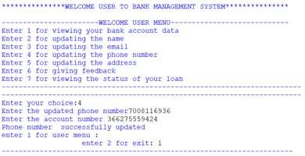

FOR UPDATING THE ADDRESS:
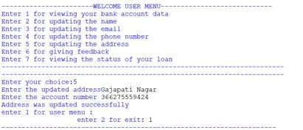

FOR GIVING FEEDBACK:
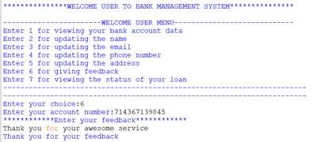

- PYTHON
- MY SQL
- ARIHANT COMUTER SCIENCE WITH PYTHON
- WIKIPEDIA

